Tutorial Quiz 3: Clinical Utility

Problem statemen

We want to estimate the utility of an algorithm designed to provide a differential diagnosis of Lupus or Rheumatoid arthritis from electronic medical records. The algorithm provides two alerts:

Alert1 = Lupus (LU)

Alert2 = Rheumatoid arthritis (RA)

And has a predictive performance defined by the following table:

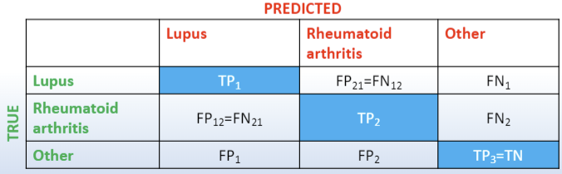

|  |  |  |  |  |
| --- | --- | --- | --- | --- |
|  |  | Predicted | | |
|  |  | Lupus | Rheumatoid arthritis | Other |
| True | Lupus | TP1 | FP21 = FN12 | FN1 |
| Rheumatoid arthritis | FP12 = FN21 | TP2 | FN2 |
| Other | FP1 | FP2 | TP3 = TN |

Question 1

1.Usual care produces no actions

2.Algorithm’s alerts always produces actions

3.We have the following utilities:

Associated with alert 1:

A1 is the utility for LU patients for which LU action has taken place

A12 is the utility for RA patients for which LU action has taken place

A13 is the utility for other patients for which LU action has taken place

Associated with alert 2:

A2 is the utility for RA patients for which RA action has taken place

A21 is the utility for LU patients for which RA action has taken place

A23 is the utility for other patients for which RA action has taken place

Associated with no alert:

I3 is the utility for other patients for which no action has taken place

I1 is the utility for LU patients for which no action has taken place

I2 is the utility for RA patients for which no action has taken place

Express the expected utility as a function of the following variables:

B1 = (A1-I1) Represents the net benefit of action for LU

B2 = (A2-I2) Represents the net benefit of action for RA

C21 = (I1-A21) = Represents the net harm/cost of RA action for LU patients

C12 = (I2-A12) = Represents the net harm/cost of LU action for RA patients

C1 = (I3-A13) = Represents the net harm/cost of LU action for other patients

C2 = (I3-A23) = Represents the net ham/cost of RA action for other patients

N1 = LU patients

N2 = RA patients

N3 = Others

Question 1 help

Start by building a utility tree in this way:

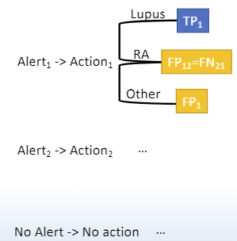

Utility Tree

**Alert1 (Lupus):**

1. **LU (True Positive | TP1)**:
   * Utility: A1
   * Net benefit: B1
   * Number of patients: TP1
2. **RA (False Positive | FP12 = FN21)**:
   * Utility: A12
   * Net harm: −C12
   * Number of patients: FP12=FN21
3. **Other (False Positive | FP1)**:
   * Utility: A13
   * Net harm: −C1
   * Number of patients: FP1

**Alert2 (Rheumatoid Arthritis):**

1. **RA (True Positive | TP2)**:
   * Utility: A2
   * Net benefit: B2
   * Number of patients: TP2
2. **LU (False Positive | FP21 = FN12)**:
   * Utility: A21
   * Net harm: −C21
   * Number of patients: FP21 = FN12
3. **Other (False Positive | FP2)**:
   * Utility: A23
   * Net harm: −C2
   * Number of patients: FP2

**No Alert:**

1. **Other (True Negative | TN)**:
   * Utility: I3
   * Number of patients: TP3 = TN
2. **LU (False Negative | FN1)**:
   * Utility: I1
   * Number of patients: FN1
3. **RA (False Negative | FN2)**:
   * Utility: I2
   * Number of patients: FN2

**Expected Utility for Alert1 (Lupus):**

EUAlert1=TP1⋅B1+FP12⋅(−C12)+FP1⋅(−C1)

**Expected Utility for Alert2 (Rheumatoid Arthritis):**

EUAlert2=TP2⋅B2+FP21⋅(−C21)+FP2⋅(−C2)

**Expected Utility for No Alert:**

EUNoAlert=TN⋅I3+FN1⋅I1+FN2⋅I2

Question 2

Write down the expression for the expected clinical utility gain of the algorithm when compared to usual care, which in this case corresponds to no action:

EUG (algorithm) = EU(algorithm) – EU(no action)

EUalgorithm = EUAlert1+EUAlert2 + EUNoAlert

=(TP1⋅B1+FP12⋅(−C12)+FP1⋅(−C1))+(TP2⋅B2+FP21⋅(−C21)+FP2⋅(−C2))+(TN⋅I3+FN1⋅I1+FN2⋅I2)

EUnoaction = N1⋅I1+N2⋅I2+N3⋅I3

EUGalgorithm = EUalgorithm − EUnoaction

= TP1⋅B1 - FP12⋅C12 - FP1⋅C1 + TP2⋅B2 - FP21⋅C21 - FP2⋅C2 + TN⋅I3+ FN1⋅I1 + FN2⋅I2 −N1⋅I1 - N2⋅I2 - N3⋅I3)

Question 3

3a. Write down the expression of EUG when the algorithm is perfect.

When the algorithm is perfect, it means there are no false positives or false negatives.

* TP1=N1
* TP2=N2
* TN=N3

EUalgorithm(perfect) =(N1⋅B1) + (N2⋅B2) + (N3⋅I3)

EUGalgorithm(perfect) = (N1⋅B1+N2⋅B2 + N3⋅I3) − (N1⋅I1 + N2⋅I2 + N3⋅I3)

= N1⋅(B1−I1) + N2⋅(B2−I2) = N1⋅B1 +N2⋅B2 − N1⋅I1 − N2⋅I2

3b. Write down the expression of EUG when the algorithm is randomthat is, the algorithm classifies LU patients randomly into

LU (TP1=N1/3), RA (FP12= N1/3) and Other (FN1=N1/3), and does similarly for the other groups.

* TP1 = N1 / 3
* FP12 = N1 / 3
* FN1 = N1 / 3
* TP2 = N2 / 3
* FP21 = N2 / 3
* FN2 = N2 / 3
* FP1 = N3 / 3
* FP2 = N3 / 3
* TN = N3 / 3

EUGalgorithm(random) = TP1⋅B1 - FP12⋅C12 - FP1⋅C1 + TP2⋅B2 - FP21⋅C21 - FP2⋅C2 + TN⋅I3+ FN1⋅I1 + FN2⋅I2 −N1⋅I1 - N2⋅I2 - N3⋅I3)

= 1 / 3 ⋅ (N1(B1-C12-2I1) + N2(B2-C21-2I2) – N3(C1+C2+2I3))